How to environment setup for unit testing in Laravel

There are two ways to setup environment in Laravel for testing:

**First way:**

1. Create new database in MySQL Work Bench or PHPMyAdmin for testing database.
2. Go to **phpunit.xml** file in your Laravel project.
3. See the two closed comment:

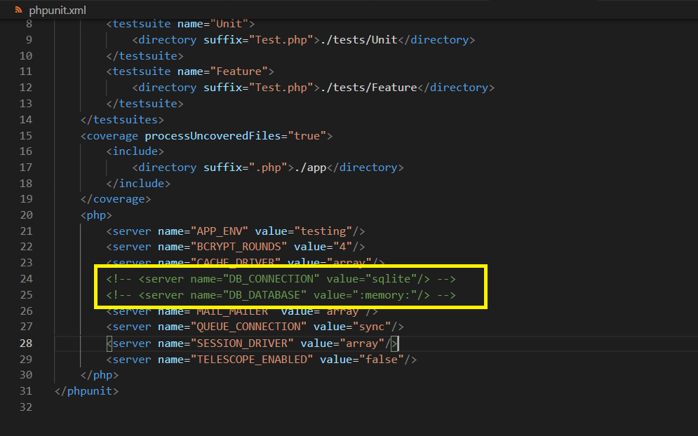

1. Open these two commands and replace your database name in value attribute.

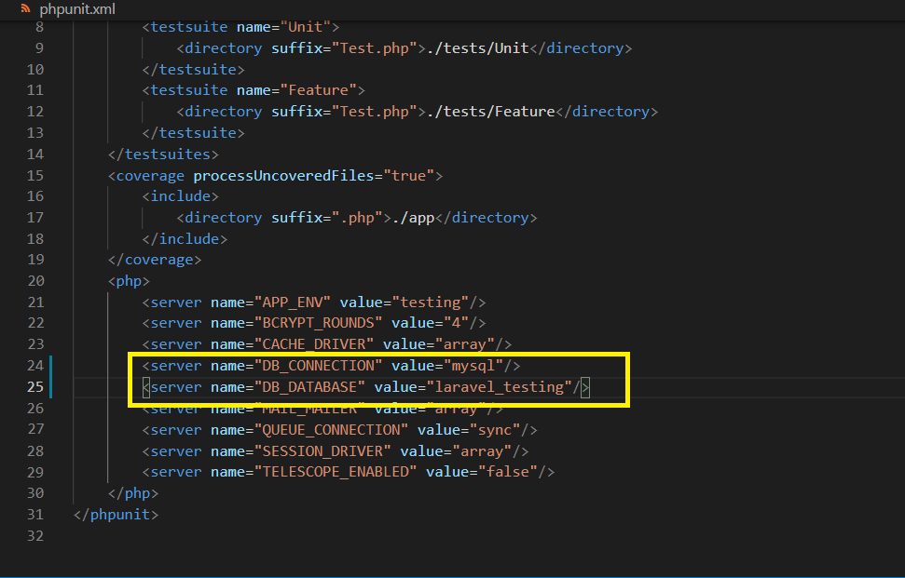

1. Next, go to **.env** file to migrate tables for your testing database and change the database name to “**your testing database name**”.

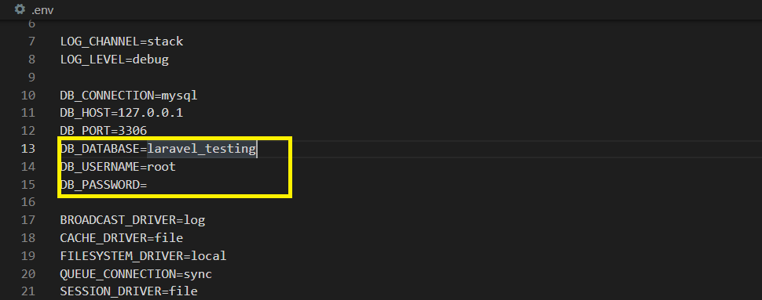

1. Run “**php artisan migrate**” and then you can test Laravel testing using another testing database.

**Second way:**

1. Create new database in MySQL Work Bench or PHPMyAdmin for testing database.
2. Copy **“.env”** file and rename this copy file as **“.env.testing” .**
3. Change the database name.

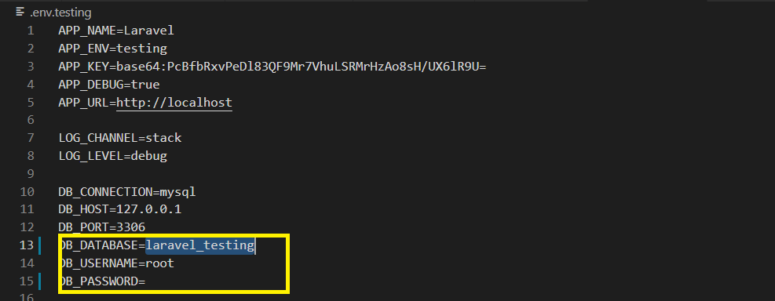

1. Run “**php artisan migrate**” and then you can test Laravel testing using another testing database.